1.Write a c program to calculate sum of two numbers.

Ans.

#include<stdio.h>

#include<conio.h>>

int main()

{

int a,b,c;

printf("Enter Two numbers:");

scanf("%d %d", &a,&b);

c=a+b;

printf(" The sum of %d and %d is \n C=%d",a,b,c);

getch();

}

Output:

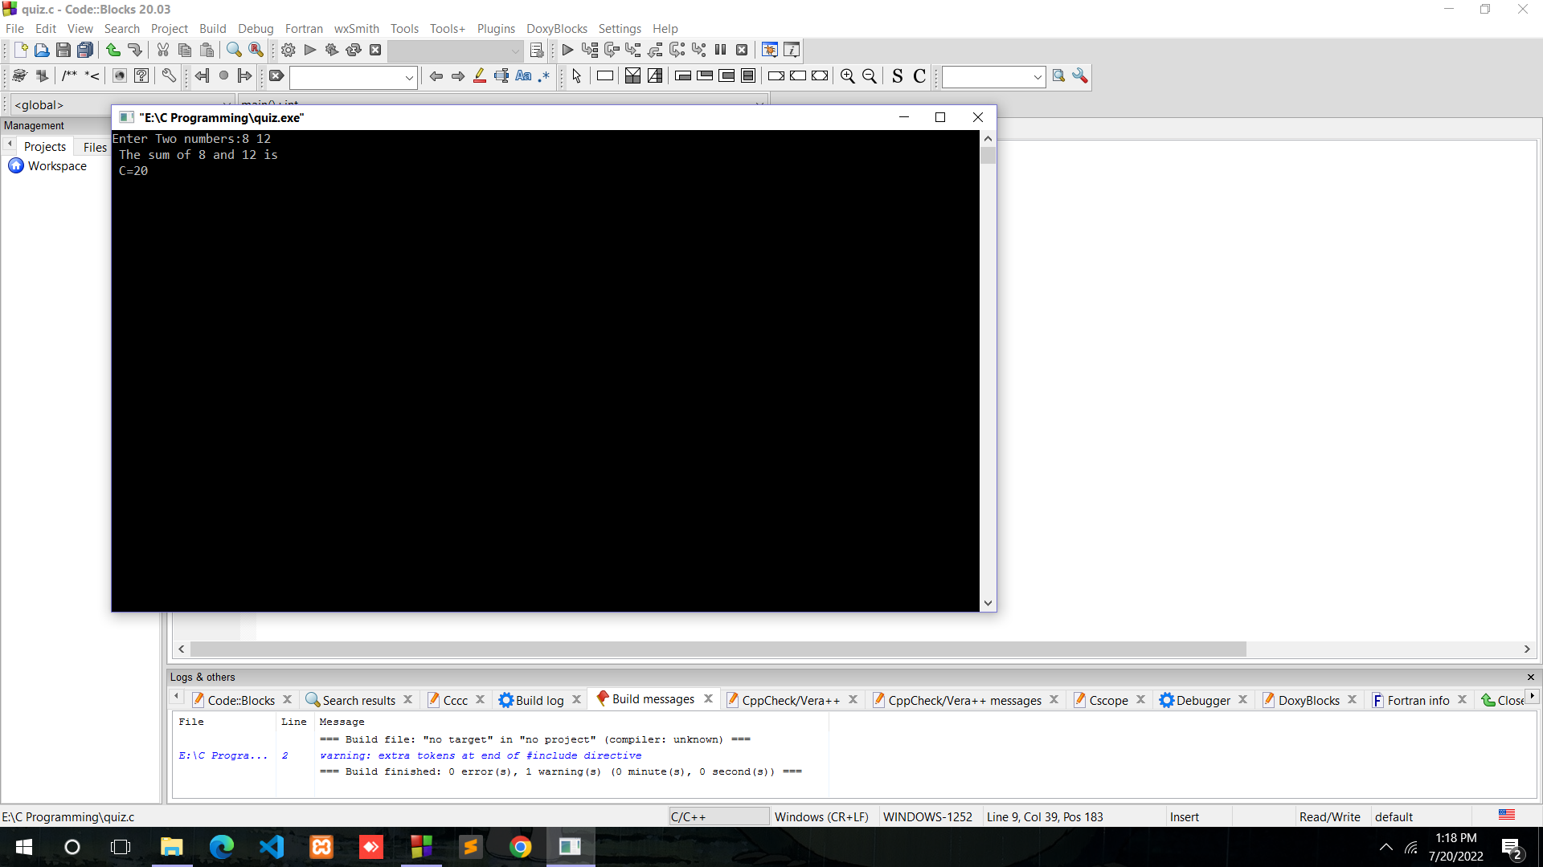

2. Write a c program to calculate the area of a circle.

Ans.

#include<stdio.h>

#include<math.h>

#include<conio.h>

int main()

{

float PI= 3.14;

float r,a; /\*r= radius of the circle and a=area of circle\*/

printf("Enter the radius of the circle: ");

scanf("%f", &r);

a= PI\*r\*r;

printf("The area of the circle with %f radius is %f",r,a);

getch();

}

Output:

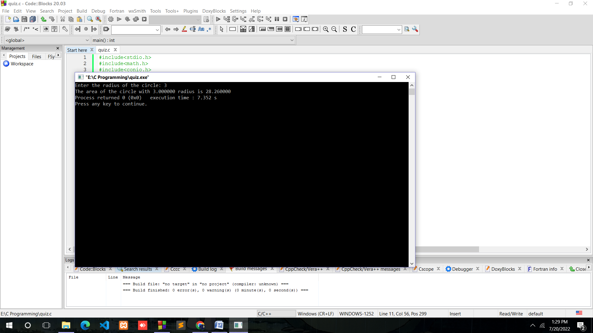

3.Write a C program to calculate the volume of a cuboid.

Ans.

#include<stdio.h>

#include<math.h>

#include<conio.h>

int main()

{

float length,breadth,height;

int volume;

printf("Enter the length,breadth and height accordingly: ");

scanf("%f %f %f",&length,&breadth,&height);

volume= length\*breadth\*height;

printf("The volume of the cuboid with length=%f breadth=%f and height=%f is \n %d ",length,breadth,height,volume);

getch();

}

Output:

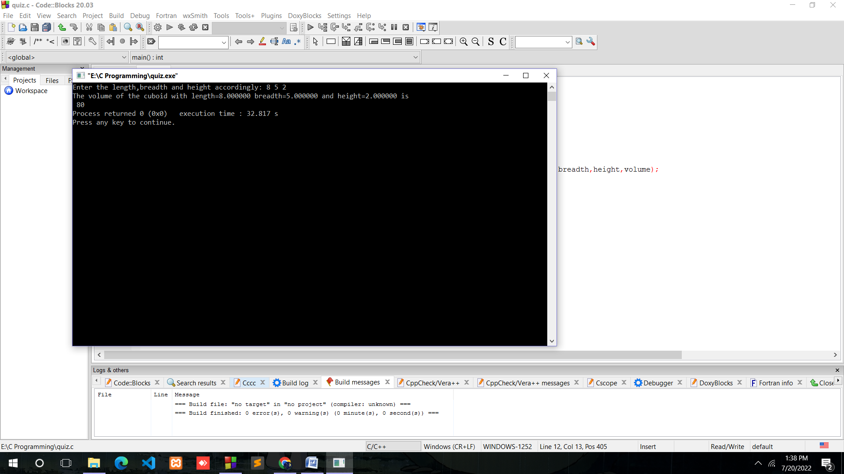

4.Write a program to calculate simple interest.

Ans.

Suppose the given problem is,

Ram had borrowed $1,000 from the bank and the rate of interest was 5%. What would the simple interest be if the amount is borrowed for 1 year?

#include<stdio.h>

#include<conio.h>

#include<math.h>

int main()

{

int time;

float rate,amount,SI;

printf("Enter the amount:");

scanf("%f",&amount);

printf("Enter the interest rate:");

scanf("%f",&rate);

printf(" Time:");

scanf("%d",&time);

SI= (rate\*amount\*time)/100;

printf("The Simple interest of amount %f for %d time is %f", amount,time,SI);

getch();

}

Output:

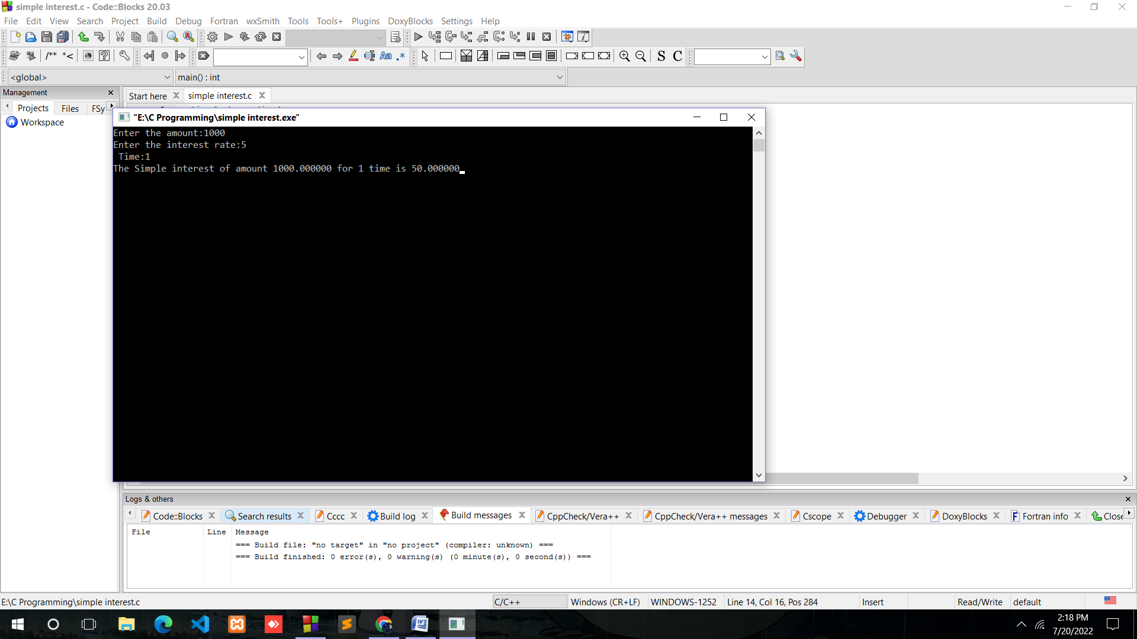

5.Write a program to calculate area of rectangle.

Ans.

#include<stdio.h>

#include<stdio.h>

#include<math.h>

int main()

{

float length,width,area;

printf("Enter length and width:");

scanf("%f %f",&length,&width);

area = (length\*width);

printf("The area of the reactangle is: %f", area);

getch();

}

Output:

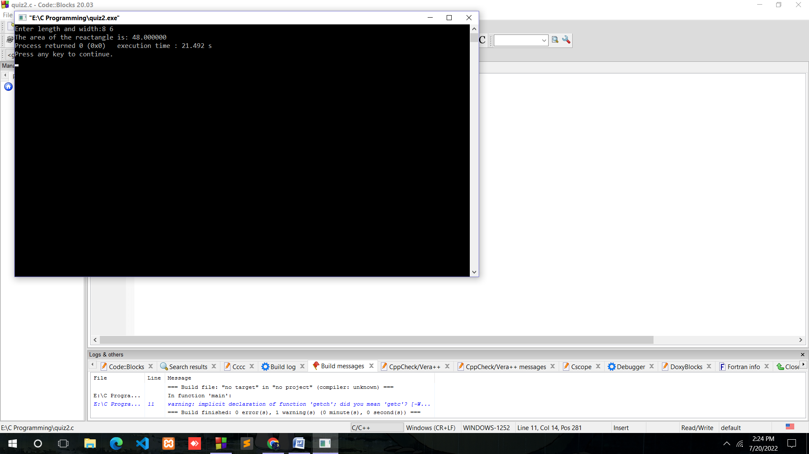

6.Write a program to calculate the average of three numbers.

Ans.

#include<stdio.h>

#include<conio.h>

#include<math.h>

int main()

{

int a,b,c,d;

printf("Enter three numbers:");

scanf("%d %d %d",&a,&b,&c);

d=(a+b+c)/3;

printf("The average:%d",d);

getch();

}

Output:

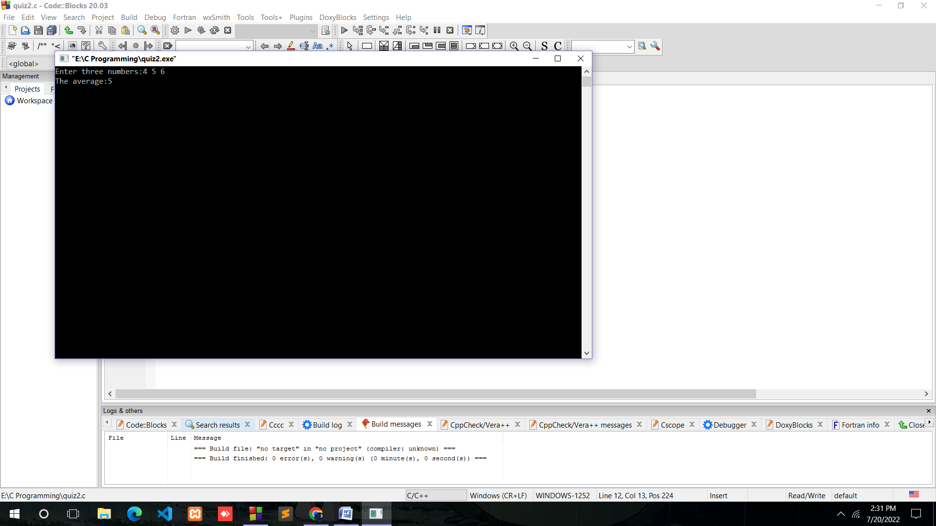

7.Write a program to find the square of a given number.

Ans.

#include<stdio.h>

#include<conio.h>

int main()

{

int a,b;

printf("Enter the number:");

scanf("%d",&a);

b=a\*a;

printf("Square of %d is %d",a,b);

getch();

}

Output:

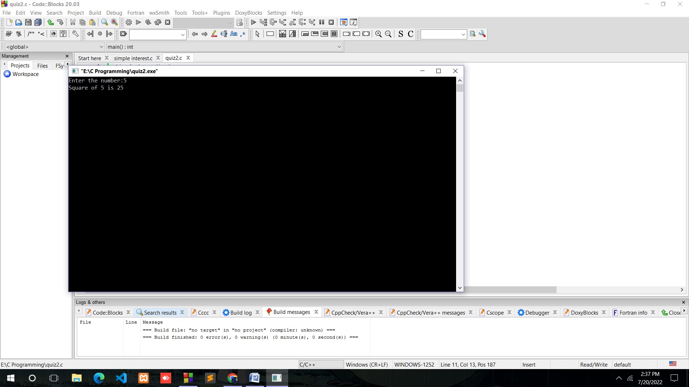

8. write a program which takes a character as input and print it’s ASCII value.

Ans.

#include<stdio.h>

#include<conio.h>

int main()

{

char a;

printf("Enter a character:");

scanf("%c",&a);

printf("The ASCII value is %c=%d",a,a);

getch()}

Output:

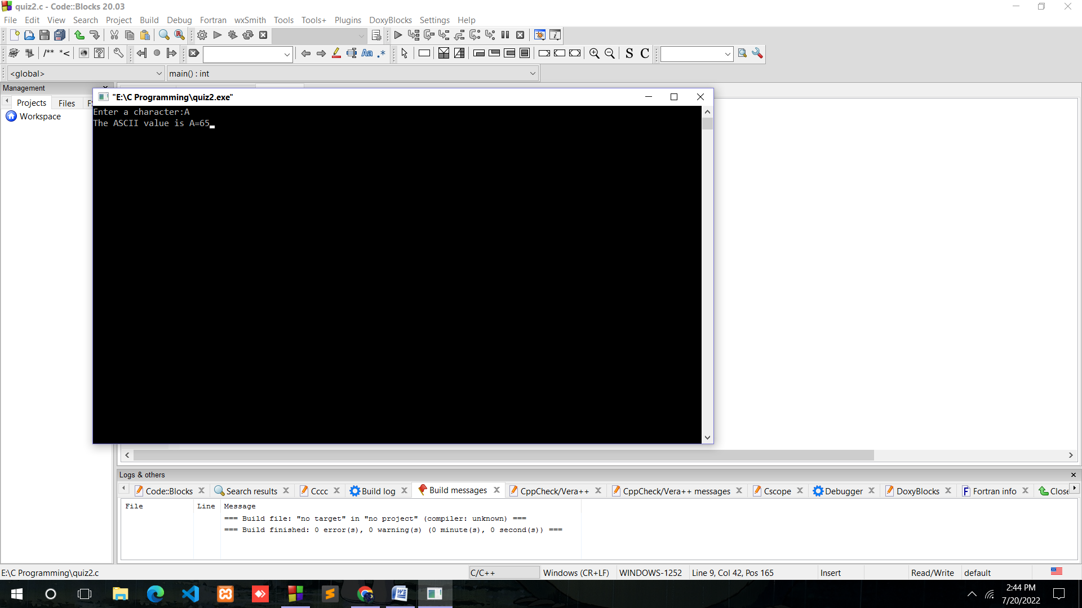

9. Write a program to calculate the profit percentage upon selling a product. Cost price and selling price are given by the user.

Ans.

#include<stdio.h>

#include<conio.h>

int main()

{

int sellingprice,costprice,profit;

float profitpercentage;

printf("Enter the cost price:");

scanf("%d", &costprice);

printf("Enter the selling price:");

scanf("%d",&sellingprice);

profit = (sellingprice-costprice);

profitpercentage=(profit\*100)/costprice;

printf("The profit percentage is: %f",profitpercentage);

getch();

}

Output:

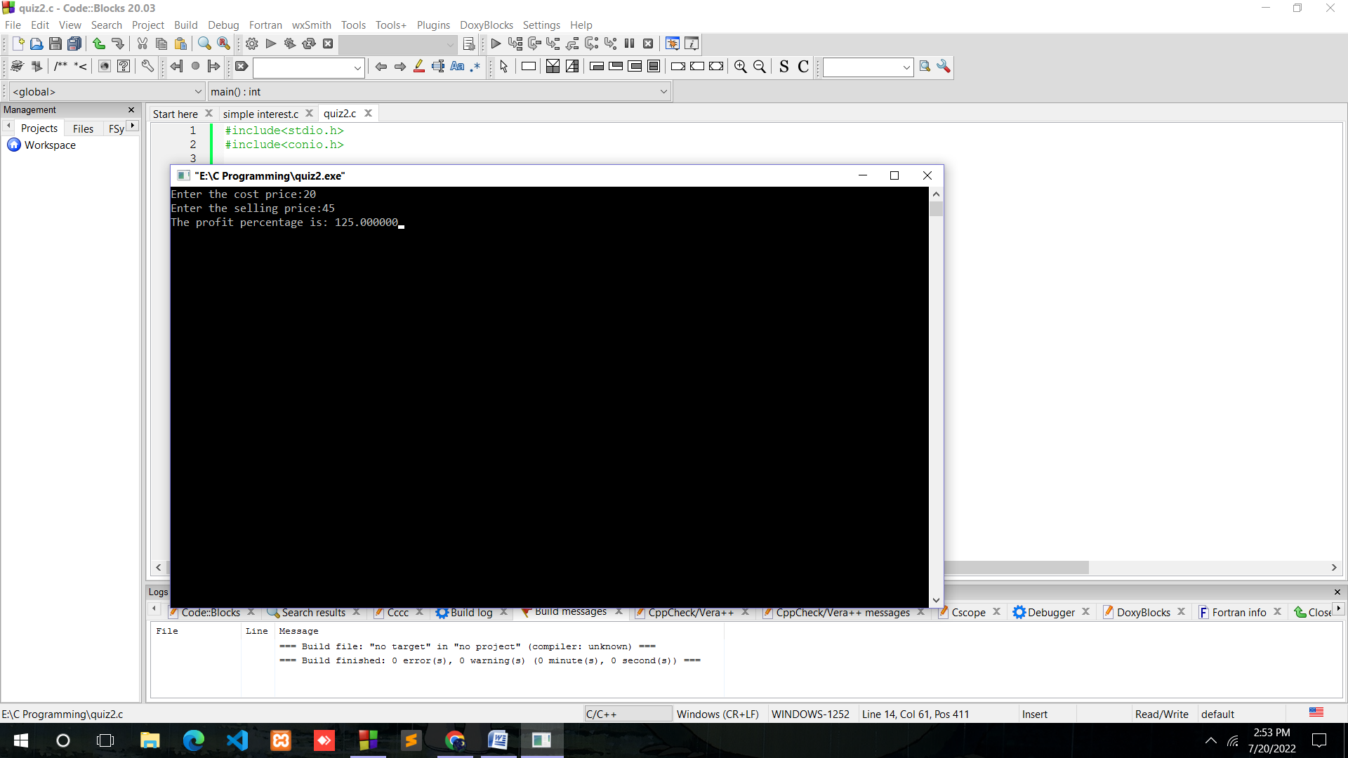

10. Write a program to calculate the area of a triangle where base and height of the triangle are given.

Ans.

#include<stdio.h>

#include<conio.h>

int main()

{

float area,height,base;

printf("Enter height:");

scanf("%f",&height);

printf("Enter base:");

scanf("%f",&base);

area =(height\*base)/2;

printf("Area of the triangle is: %f",area);

getch();

}

Output:

